1. Change the value of the connectivity parameter from 0.3 to 0.6 and report on the new value of the total journey time that you computed in R3.

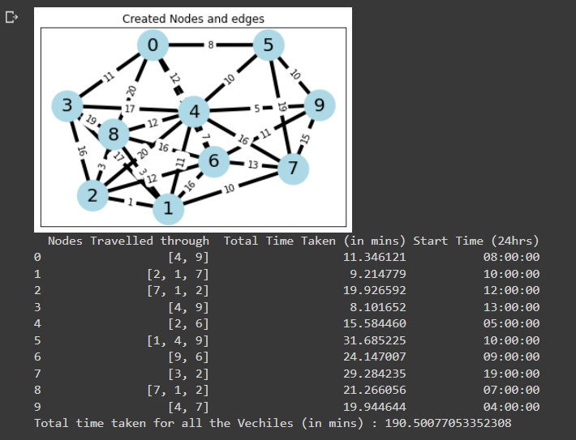

1. Change the value of the standard deviation of traffic load from 0.25 to 0.125 and report on the new value of the total journey time that you computed in R3.

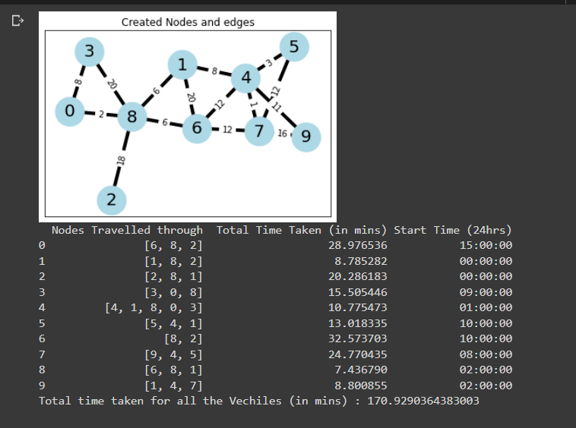

value of the standard deviation of traffic load from 0.25 to 0.125

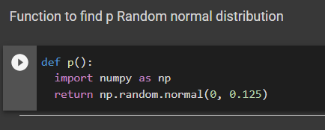

1. Explain how changes in connectivity affect changes in journey time.

Answer:

Here, when we change the connectivity from 0.3 to 0.6 we can see that the number of connections per node has increased twice and as the connectivity has increased the vehicles can travel in more possible ways in less amount of time, So the overall travel time decreases when the connectivity of the network increases and the number of nodes travelled through also reduces.

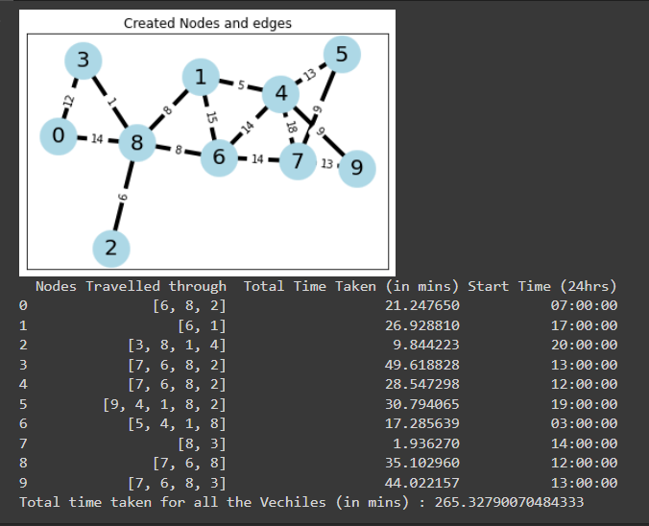



1. Explain how changes in standard deviation affect changes in journey time.

Answer:

When the Standard Deviation is reduced or increased, the Normal Distribution curve becomes thinner or fatter. Given that it represents a probability distribution curve, its area must always be 1. As a result, a thinner curve is taller and a fatter curve is shorter. Standard deviation changes only the shape of the normal distribution curve. Because it is a probability distribution curve, its area must always be 1. As a result, a thinner curve is taller, while a larger curve is shorter. Here as we reduced the sigma value from 0.25 to 0.125 the range of the curve reduces and the value of the amplitude of the curve increases, as a result the p value reduces to half and the load factor reduces. As Load factor reduces the overall time taken for each vehicle reduces. Hence the overall time for the vehicle to complete their journey reduces.

